Université Oran 2
Faculté des Lettres et Langues Étrangères
Laboratoire de Traduction et Méthodologie (TRADTEC)

Colloque International
Langues, Employabilité et EnseignementSupérieur :
Contexte (s), Référenciation et Pratiques Professionnelles
23-25 Avril 2017

Mohammed NAOUA
Université Chahid Hamma Lakhdhar- Eloued
Faculté des Lettres et Langues
Département des Lettres et Langue Anglaise

Axe : 6
Programmes et Curricula en Question

Titre de la Communication:

Teaching LSP for the Baccalaureate Examination:
What Syllabuses are we designing?

Abstract

Teaching languages for specific purposes (LSP) can be defined as the process of providing homogeneous groups of learners or trainees with specific types of instruction based on extensive analyses of their specific academic or professional communicative needs. The latter refer to the real-world situations, which learners or trainees may respectively encounter during their further studies, or in the work place. Designing syllabuses for such contexts should respond to the following criteria: homogeneity of participants, specificity of content, authenticity of task, and interaction between learners' background knowledge and syllabi content. However, this rule seems to be reversed in Algeria, where heterogeneous LSP classes of learners continue to be provided with the same program of study, which can hardly meet the requirements of one out of the seven specialties studying at the secondary cycle.
This paper attempts to conduct an empirical analysis to examine the suitability of the third year syllabus in secondary education to the pupils' communicative needs.
Keywords:Baccalaureate examination - Communicative Competence - LSP - Needs -Syllabus Design

Introduction
Teaching languages for specific purposes (LSP) refers to the type of instruction that is provided for homogeneous groups of learners or trainees who need the language to pursue their further specific academic studies, or to perform all or a part of a given job (Basturkmen, 2006, 2010; Basturkmen & Elder, 2004; Douglas, 2000, 2005, 2010; Dudley-Evans & Waters, 1998; Hutchinson & Waters, 1987; Mumby, 1998).Designing syllabuses for such contexts requires the specification of learners' communicative competences, restricting the boundaries of their subject-specialist knowledge, and describing the specific contexts that these leaners are expected to encounter during their further academic instruction, or job-related situations.
The specification of learners' communicative competencies, which encompasses areas of organizational, textual, pragmatic, sociolinguistic, and functional knowledge, enables us to place learners at different class levels. Describing their background knowledge allows us to organize them into homogeneous groups. However, the identification of their target language domains qualifies us to provide them with the most appropriate syllabuses and the most valid baccalaureate tests (Bachman & Palmer, 1996; Hyland 2006; long, 2005; Nunan,1999, 2004).
- LSP SyllabusDesign
Before describing the process of syllabus design in LSP contexts, let us first provide a definition to a syllabus. According to Strevens (1977), this document, which can serve as a guide for both teachers and learners, is:
partly an administrative instrument, partly a day-today guide to the teacher, partly a statement of what is to be taught and how, sometimes partly a statement of an approach. It is the document in which is listed, ideally, the items to be taught, in a particular course, to a particular set of defined learners, on a given number of occasions per week or day, in a given sequence, within the aim of achieving stated interim and final goals or objectives, and usually according to particular teaching techniques for each and every item (p.25).
However, the "most crucial problem" in the world of LSP, as Mumby (1978) puts it, "is how to specify validly the target communicative competence" (p.6). Solving this problem requires syllabus designers to start with the learners, rather than with lessons. This step enables them to specify the participants' communicative abilities, identify the target situations, which, they may encounter during their real-life studies, and to which test scores, are intended to be generalized, and then they determine the participants' communicative needs."Once this is done, the next part of the problem is how to convert needs into syllabus content" (p. 6).
- LSP Learners' Communicative Language Abilities
Based on Hymes (1992), Savignon (1972), Canale and Swain (1980), Widdowson (1983), Bachman (1990, 1991), and Bachman and Palmer (1996), we can say that communicative language ability (CLA) has continually been defined with reference to competence for grammar and competence for use. Competence for grammar or communicative competence refers to "the relationship and interaction between grammatical competence, or knowledge of the rules of grammar, and sociolinguistic competence, or knowledge of the rules of language use" (Canale & Swain, 1980, p.6). Competence for use or communicative performance concerns "the realization of these competencies and their interaction in the actual production and comprehension of utterances"(p.6).
  - Specific Communicative language ability (SCLA)
Applied linguists consider Bachman and Palmer's model of communicative language ability (CLA) as the most comprehensive one (McNamara & Roever, 2006; Luoma, 2004).The authors theorize that CLA consists of two main components: language knowledge (LK) and metacognitive strategies. Purpura (2004) defines knowledge as "a set of informational structures that are built upthrough experience and stored in long-term memory. These structures include knowledge of facts that are stored in concepts, images, networks, production-like structures, propositions, schemata and representations (Pressley, 1995)" (p. 85). However, LK can be considered as "a mental representation of informational structures related to language" (p. 85). In Bachman and Palmer's model, LK encompasses four types of knowledge: grammatical, textual, functional, and sociolinguistic. As for far the metacognitive processes are concerned, these can be thought of as a "set of metacognitive components or strategies, which can be thought of as higher order executive processes that provide a cognitive management functions in language use, as well as in other cognitive activities" (Bachman & Palmer, 1996, p. 70).
  - Douglas's Model of Specific Language Ability (SCLA)
Building largely upon Bachman (1990, 1991) and Bachman and Palmer (1996), Douglas (2000) proposes a model for specific communicative language ability comprising three interacting components: language knowledge, background knowledge (BK), and strategic competence. For language knowledge, Douglas uses the same terms and interpretations as in Bachman and Palmer (1996). BK can be seen as the "frame of reference based on past experience which we use to make sense of current input and make predictions about that which is to come" (Douglas, 2000, p. 35). In general education courses, or tests, BK is considered as one of the construct irrelevant variances since it invalidly leads some types of learners, or examinees to be favored whether in understanding lessons, or in obtaining invalidly higher marks at the expense of their colleagues who are not accustomed to this type of BK (Messick, 1995). Conversely, in LSP courses or testing where participants are homogenous, BK forms one of the basic components of their SCLA. In other words, the more courses or tests are field-specific, the more learners or testees' motivation is maximized. Turning now to strategic competencies, these can be seen as mental processes which enable, on the one hand, learners' LK to interact with their BK, and allow for an interaction between the previous competencies and the external context (courses/tests) on the other (Alderson & Bachman, 2000-2006; Bachman, 1990, 1991; Bachman & Palmer, 1996; Douglas, 2000, 2001, 2005, 2010, 2013).
- Target Language Use Domains (TLUD)
Bachman and Palmer (1996) define target language use domains as "a set of specific language use tasks that the test taker (or the learner) is likely to encounter outside the test itself (or the classroom)" (p. 44). The authors classify TLUD into two types: real-life domains and instructional domains. The former describe the situations where language is used for real communicative purposes; while the latter delineates the contexts "in which language is used for the purpose of teaching and learning language" (p. 44).
  - Target Language Use Tasks
Having defined TLUD and the type of tasks created by language users, we find it appropriate to this research to define language use in order to move smoothly to specific language tasks. Language use "can be defined as the creation or interpretation of intended meanings in discourse by an individual, or as the dynamic or interactive negotiation of intended meanings by two or more individuals in a particular situation" (Bachman & Palmer, 1996, pp. 61-2). Now if language tasks are used within a purely specific and particular context, we refer to it as 'target language use task' (TLUT).This, of course, what distinguishes general language teaching from LSP teaching. Basturkmen and Elder (2004; as cited in Naoua, 2016b) define the latter as:
The teaching and research of language in relation to the communicative needs of speakers of a second language in facing a particular workplace, academic, or professional context. In such contexts[,]language is used for a limited range of communicative events…Analysis of language in such events generally reveals that language is used in constrained and fairly predictable ways…LSP courses usually focus on the specific language needs of fairly homogeneous groups of learners in regard to one particular context referred to as the target situation…The aim of such courses is to help the learners deal with the linguistic demands of their academic, workplace, or professional target situations. LSP courses can be “pre-experience” or “post-experience” (p. 3).
Hutchinson and Waters (1987) organize the world of LSP into three main divisions: English for science and technology, English for business and economics, and English for social sciences. Then, each division is organized into English for academic purposes (EAP) and English for occupational purposes (EOP) (see Fig 1.). The first type"concerns the learners who need the language for educational purposes such as pursuing studies in a given academic field of interest [while] the second category 'EOP' refers to the use of language with the intention of performing part or all of a job (Douglas, 2000)" (Naoua, 2016a, as cited in Naoua, 2016b, p. 6).
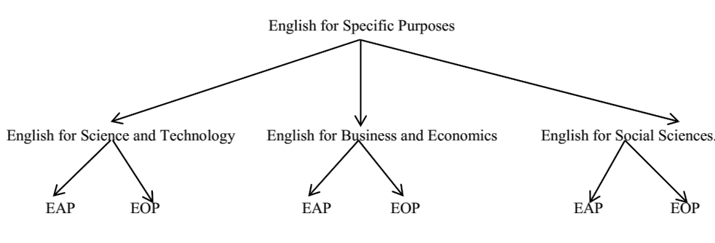
Fig 1: Source: Naoua, 2016b, p.3
- LSP Syllabus Design
LSP Syllabus design can be seen as the process, which involves providing leaners with the course content that meets and develops their language competencies, that engages their topical or background knowledge, and that maximizes their motivation and interaction with the course content by reinforcing authenticity between instructional tasks, and target language use tasks (Basturkmen, 2006, 2010; Long, 2005; Mumby, 1978; Douglas, 2013). What is worth mentioning here is that the selection, sequencing, grading, and evaluation of content, should always conclude an extensive process of needs analysis that intends to appropriately specify learners' communicative needs (Bachman & Palmer, 1996; Dudley-Evans & St Johns, 1998; Long, 2005; Hutchinson &Waters, 1998; Mumby, 1978). In Short, LSP instruction "should focus on the learner and the purposes for which he requires the target language, and the whole language programme follows from that" (Mumby, 1978, p. vi).
- Communicative Needs
We can define communication needs as the skills and tasks, which enable learners, or workers to communicate appropriately in the target situation. These involve diagnosing the areas of strength and weakness in learners' communicative competence, providing them with the content that stimulates their topical knowledge, and corresponds to real-life target academic or job-related contexts. However, this process should not be based on expert intuition, but on an extensive needs analysis which refers to:
The techniques for collecting and assessing informationrelevant to course design: it is the means of establishing the how and what of acourse. It is a continuous process, since we modify our teaching as we come to learnmore about our students….Needs is actually an umbrellaterm that embraces many aspects, incorporating learners’ goals and backgrounds,their language proficiencies, their reasons for taking the course, their teaching andlearning preferences, and the situations they will need to communicate in. Needscan involve what learners know, don’t know or want to know, and can be collected and analysed in a variety of ways (e.g. Brindley, 1989; Brown, 1995) (Hyland, 2006, pp. 73-74).

- Methodology
This paper attempts to conduct an empirical analysis to examine the extent of suitability of the third year syllabi in Algerian secondary education to LSP learners' target needs on the one hand, and to the baccalaureate examination on the other. Since the information we intend to elicit is fully available in documents, this study focuses on gathering tools by means documentary sources, which calls for implementing the techniques of the analytic method.
  - Describing the Participants
The population under investigation includes three main types of subjects: economics and management, scientific, (Maths and biology) and technology streams. The latter are classified into four sub-specialties: civil, electrical, mechanical, and processing engineering.
  - Describingthe Relevant Data gathering Tools
Documentary sources can be organized with reference to their authorship and access (Jupp, 2006). The former identifies the origin of these files; however, the latter specifies the extent to which these files are available for use by researchers. Research methodologists classify 'authorship' into official (governmental) and private (non-governmental). Concerning 'access', it describes closed, restricted, open-archival, and open-published documents. The documentary sources relevant to this researchare the most accessible and are usually in general circulation. These include: (1) the third year syllabus, (2) their subject-specialist programs of study, and (3) the Baccalauréeat English tests from 2010 to 2016.
- Discussion and Results
  - Delimiting the Target Language Situations in Algerian Secondary Education
Based on Bachman and Palmer's (1996) definition of target language use tasks (see page. 5), we can say that target language situations in Algerian secondary education encompass the academic contexts where pupils can produce and comprehend 'intended meanings' of discourse in relation to their subjects of specialism. To explain this point, we can speak of English for economics and management, for sciences (Maths, and biology), and for technology (civil, electrical, mechanical, and processing engineering).
  - Analysis of the Third Year Syllabus
According to the Ministry of National Education (MNE) (2014-2015) the third year cousebook 'NewProspects'" is designed in such a way that each stream of students preparing their Baccalauréat will be able to choose (with their inspector/teacher) the four mandatory units which will be more directly related to their field, which means that the students needn’t work on all six units" (p.3[emphasis in original]). The four themes intended for economics and management, sciences, and technology streams include the following (see Table 1): unit (2) Ethics in Business: Fighting Fraud and Corruption; unit (4) Advertising: Consumers and Safety; unit (5) Astronomy and the Solar System; and finally, unit (6) we are a Family: Feelings and Emotions.
Table 1: The Third Year Syllabus
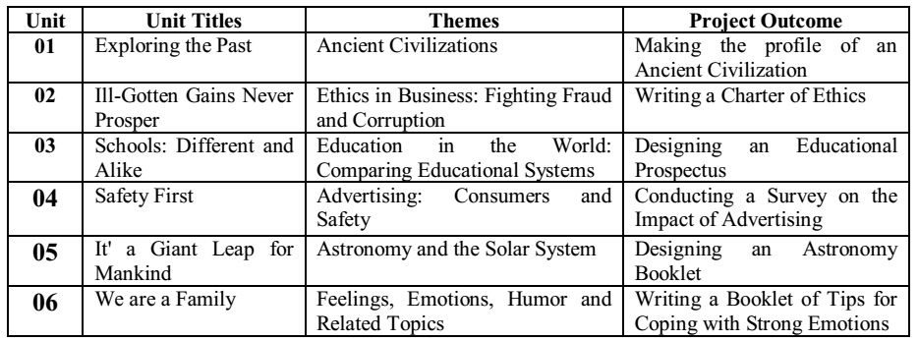
Source, Naoua, in press,a p.7
The MNE (2014-15b) stresses that the third year syllabus "caters to the needs of the major Baccalauréat streams. We have tried to strike a balance between topics related to science and technology and others related to language and humanities" (p.3, [our emphasis]). According to the Ministry, this syllabus provides situations where "learners are given opportunities to process content relating to their lives and backgrounds" (p.9). However, our examination of the themes in the programs of study suggests that 50% (units 2 and 4) of its content falls into the preferences of one single stream, economics and management. This means that the background knowledge and the specific communication needs of the other six specialties have completely been discounted. This behavior implies that syllabus design have been implemented whether on experts' intuition, or on random basis; but certainly, not on needs analysis.
  - The BAC English Tests of Economics, Scientific, and 'Maths Technique' Branches
As we see in Table (2), during each baccalaureate session, the pupils are provided with two optional themes. In 2010, the test themes were about child labor, and advertising; in 2011, advertising, and astronomy; in 2012, business companies performance, and astronomy;in 2013, child labor and Hubble space telescope; in 2014, consuming habits, and counterfeited paper currencies; and in 2015, life on the moon, and eating habits in America.
Table 2: BAC English Test topics from 2010 to 2015
Source, Naoua, in press,a p.7
Now a careful examination of the BAC topics administered to these specialties during six sessions (2010-2015) (see Tables 2, and 3) implies that out of twelve tests, eight topics emerged form units (2) Ethics in Business: Fighting Fraud and Corruption, and (4) Advertising: Consumers and Safety. However, the other four topics focused astronomy. In the same way as in syllabi content, the background knowledge, as a basic constituent of pupils' specific communicative ability has once again been discounted, which questions the concept of validity of the syllabi, and the BAC tests in these streams.
Table 3: The BAC English Tests responding to Economics and Management's Needs
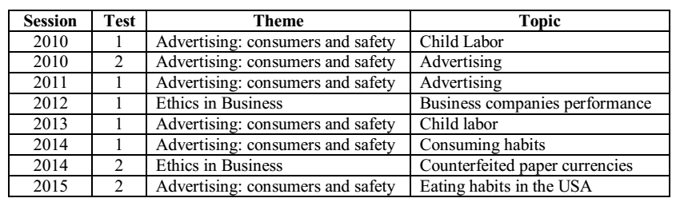Source: Naoua,in press, p.8

- Recommendations
The deficiency to specify leaners' communicative competencies and the failure to provide them with the most appropriate syllabi and valid measurement instruments leads us to propose the following list of recommendations:
- Syllabus designers should be composed of three types of informants: applied linguists, subject-specialist informants, and teachers and inspectors. The first group can specify learners' competencies, their communication needs, and the contexts they are supposed to encounter. The second group can help in providing the subject-specialist cues relevant to the pupils' background knowledge. The third group, working on the ground, can help in specifying learners' present levels, and determine their lacks.
- The specification of the pupils' communicative competencies should delimit the pupils' present and target communication needs, what type of uniform background knowledge is to taught and tested, and explain how strategic competence can engage learners' competencies to interact with what to be taught.
- The target language contexts should delineate the narrow scope field of learners' specialties. For example, 'Maths technique' branches should be provided with four different content syllabi.
- Syllabus design should crown an extensive process of learners' needs analysis, or at least it should be comparable to their fields of specialty
- Teacher training should reinforce LSP literacy amongst trainees.
- The baccalaureate English tests should be as engaging as possible of the examinees' background knowledge.
- The construct validity of tests should not be measured on the basis of the extent of correspondence between exams and syllabi, but on the extent of authenticity between the test content and the pupils' very specific background knowledge.
Conclusion
This paper conducted an empirical analysis to measure the extent to which LSP syllabuses intended for the Algerian baccalaureate examination, have achieved the purposes for which they have been designed. The results of the study revealed several deficiencies relevant to syllabus designers, the specification of the pupils' communicative competencies, and communication needs, as well as the failure to precisely delimit the target contexts where LSP pupils are supposed to use English for specific communicative purposes. Concerning the first point, the research has revealed that syllabus designers have not succeeded to provide leaners with the appropriate programs of study. As far as the second point is concerned, the failure to specifythepupils' specific communicative competencies has affected the processof describing their communication needs. However, providing these different specialties with a uniform syllabus has undermined the LSP principles suggesting that programs of study in these streams should be as engaging as possible of their background knowledge.
The research concluded with a list of recommendations intended to improve the process of syllabus design in Algerian secondary education.

Reference List
Alderson, J, C., & Bachman, L. F. (Eds.). (2000–2006). The Cambridge language assessment series. Cambridge: Cambridge University Press.
Bachman, L. F. (1990). Fundamental considerations in language testing. Oxford: OxfordUniversity Press.
Bachman, L. F. (1991). What does language testing have to offer? TESOL Quarterly, 25 (4), 671-704. Online http://www.jstor.org.www.sndl1.arn.dz/stable/pdfplus/3587082.pdf.
Bachman, L. F., & Palmer, A. S. (1996).Language testing in practice.Oxford: Oxford University Press.
Basturkmen , H. (2010). Developing courses in English for specific purposes . Basingstoke, UK : Palgrave/ Macmillan.
Basturkmen, H. (2006). Ideas and options in English for specific purposes.Mahwah, NJ: L. Erlbaum Associates.
Basturkmen, H., & Elder, C. (2004).The practice of LSP. In A. Davies & C. Elder (Eds.), The handbook of applied linguistics (pp. 672–694). Oxford: Blackwell.
Canale, M., & Swain, M. (1980). Theoretical bases of communicative approaches to second language teaching and testing. Applied Linguistics, 1(1), 1–47. From http://applij.oxfordjournals.org/content/I/1/1.full.pdf+html
Douglas, D. (2000). Assessing languages for specific purposes. Cambridge: Cambridge University Press.
Douglas, D. (2001). Three problems in testing language for specific purposes: Authenticity, specificity and inseparability. In C Elder et al (Eds). Experimenting with uncertainty:Essays in honour of Alan Davies (pp. 45-51). Cambridge: Cambridge University Press.
Douglas, D. (2005). Testing Language for Specific Purposes.(2005).In H. Hinkel (ed.), Handbook of research in second language teaching and learning. (pp.857-868). Mahwah, NJ: London, UK: Lawrence Erlbaum Associates Publishers
Douglas, D. (2010). Understanding language testing. London: Hodder Education. Mahwah, NJ: London,, UK: Lawrence Erlbaum Associates Publishers.
Douglas, D. (2013). ESP and assessment. In B, Paltridge& S, Starfield (Eds). The handbookof English for specific purposes, (pp. 367-383). England, Chichester: John Wiley & Sons, Inc
Halliday, M.A.K., & Martin, J.R. (1993).Writing science: Literacy and discursive power. London: The Falmer Press.
Hutchinson, T., & Waters, A. (1987).English for specific purposes: A learning-centered approach.Cambridge: Cambridge University Press.
Hyland, K. (2006) English for academic purposes: An advanced resource book (London: Routledge).
Hymes, D. (1972). On communicative competence. In J. Pride & J. Holmes (Eds.),Sociolinguistics (pp. 269–293). Harmandsworth, UK: Penguin.
Jupp, V. (2006).Documents and Critical Research. In J Sapsford.,& V, Jupp (Eds). Data collection and analysis (2nded, pp.272-290). London: SAGE Publications; The Open university
Long, M, H. (Ed). (2005). Second language needs analysis. Cambridge: Cambridge University Press.
Luoma, S. (2004).Assessing speaking. Cambridge: Cambridge University Press.
McNamara, T., & Roever, C. (2006).Language Testing: The social dimension.Oxford: Blackwell Publishing.
Ministry of National Education. (2014-2015b). New Prospects: Teachers' book. Alger: The National Authority for School Publications
Ministry of National Education.(2014-2015a). New Prospects: Pupils' Course book. Alger: The National Authority for School Publications
Mumby, J. (1978). Communicative syllabus design.Cambridge, UK: Cambridge University Press.
Naoua, M. (2016a).An evaluation of English language testing in the Baccalaureate examination.Unpublished Ph.D. Thesis. Mentouri Brothers University, Constantine.
Naoua, M. (2016b). Specialized discourse in language tests. pp. 1-12. Colloque International Les Discours Spécialisés: Enjeux, Descriptions et Pratiques. October19-21, 2016, Gabes, Tunisia.
Naoua, M. (in press). Assessing ESP in 'Math Technique' branches: The case of civil engineering BAC English tests from 2010 to 2015.Revues des sciences Humaines, Université de Constantine 1.
Nunan, D. (1989). Designing tasks for the communicative classroom. Cambridge: CambridgeUniversity Press.
Nunan, D. (2004). Task-based language teaching. Cambridge: Cambridge University Press.
Purpura, J. A. (2004).Assessing grammar. Cambridge: Cambridge University Press.
Savignon, S, J. (1972). Communicative competence: An experiment in foreign language teaching.Philadelphia, PA: Center for Curriculum Development.
Strevens, P. (1969). The Medium of instruction (mother-tongue/second language) and the formation of scientific concepts.Document Resume. Washington: U.S. Department of Health, Education and Welfare Office of Education.
Strevens, P. (1972).Technical, technological, and scientific English(TTSE). Paper presented at the international association of teachers of English as a foreign language conference in London. Document Resume. Washington: U.S. Department of Health, Education and Welfare Office of Education.
Strevens, P. (1977). New orientations in the teaching of English. Oxford: Oxford University Press.
Strevens, P., et al. (1971).Science and Technology in a Second Language: Papers from a Seminar Held at the University of Birmingham from 27th to 29 March. Document Resume. London: Centre for Information on Language Teaching.
Swales , J. M. ( 1990 ). Genre analysis: English in academic and research settings. Cambridge: Cambridge University Press.
Swales, J. (2000).Languages for specific purposes.Annual Review of Applied Linguistics 20, 59–76. Online http://dx.doi.org/10.1017/S026719050020
Widdowson, H. G. (1983). Learning purpose and language use. London: Oxford University Press

