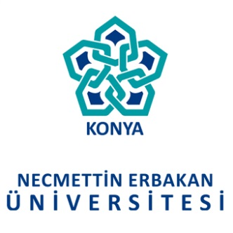
الهيئة | العنوان الالكتروني | البلد | تاريخ إبرام الاتفاقية | مدة الاتفاقية
NECMETTIN ERBAKAN UNIVERSITY | https://www.konya.edu.tr/ | KONYA, TURKEY | 04/07/2017 | 5 سنوات

ملخص الاتفاقية:
The universities agree to encourage the development of the following exchange programs
based on their respective academic and educational needs:
- Exchange of Faculty
- Exchange of Students (undergraduate and/or graduate)
- Joint Supervision of M. S. and Ph. D. Students
- The Development of Curricula
- Exchange of Academic Information and Materials
- Exchange of Periodicals and Other Publications
- Organization of Joint Research Programs
- Organization of Joint Conferences
- Organization of Other Academic Exchanges Agreeable to both Universities

